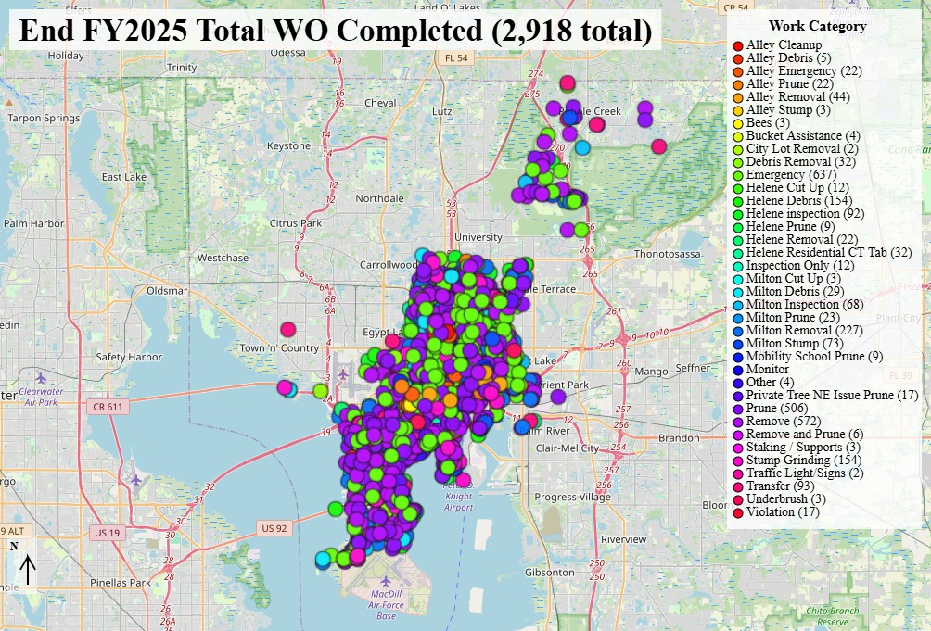
State of the Forest End FY2025
The Annual Internal Report on the
City of Tampa - Forestry Division Program
November 2025

Prepared by:
Eric Muecke, RF, CUCF
Urban Forestry Manager
NC Registered Forester 1673, SAF Certified Urban and Community Forester
ISA Certified Arborist IL-0709, TRAQ qualified
City of Tampa / 3402 W. Columbus Drive / Tampa, Florida 33607
p: (813)274-5137 /e: Eric.Muecke@tampagov.net

November 2025

Welcome to the FY2025 State of the Forest report!

The State of the Forest is an internal report on the accomplishments of the City of Tampa Forestry Division for Fiscal Year 2025.

The highlights include:
- The Tree-Mendous Tampa planting program – a free tree-planting program for residents requesting trees in the right-of-way in front of their house.
- A summary of work orders associated with Hurricanes Helene and Milton completed in FY2025.
- A review of the completed tree emergency, tree removal and tree pruning work orders.
- A review of new assignments completed since Forestry was moved from the Parks and Recreation Department to the Neighborhood Enhancement Department in March 2025.
- An overview of the interaction with other City Departments/Entities also involved with trees and our urban forest canopy.
- A map of the current work orders awaiting completion in FY2026.

After reviewing the materials, we compare Tampa to other communities similar in size and their Forestry Programs. We evaluate the Strengths, Weaknesses, Opportunities, and Threats to our Forestry Team and the urban forest. We wrap up the report with recommendations for improvement to the Forestry program.

As always, the City of Tampa Forestry Division looks forward to Transforming Tampa’s Tomorrow!

Best,
E.P. Muecke
Eric Muecke, RF, CUCF
Urban Forestry Manager
NC Registered Forester 1673, Certified Urban and Community Forester,
ISA Certified Arborist IL-0709, TRAQ qualified

City of Tampa – Forestry Division
FY2025 State of the Forest Report
Executive Summary
Prepared by: Eric Muecke, RF, CUCF
November 2025

Overview
The FY2025 State of the Forest report provides a comprehensive internal review of the City of Tampa’s Forestry Division. It highlights key accomplishments, identifies operational challenges, and outlines strategic recommendations to improve the health, resilience, and management of Tampa’s urban forest.

Key Accomplishments
- 2,918 work orders completed, a 63% increase over the historical average.
- 1,413 emergency responses (48% of total work), including significant efforts following Hurricanes Helene and Milton.
- 433 trees planted through the Tree-Mendous Tampa program.
- 95 work orders transferred to other departments due to jurisdictional limitations.
- SWOT analysis conducted to assess internal capabilities and external risks.

Major Challenges
- Lack of a public tree ordinance assigning clear responsibility for public tree management.
- No citywide street tree inventory, limiting proactive maintenance and planning.
- High volume of emergency work during storm season (June–November) disrupts routine operations.
- Aging tree population and increasing risk of failure, leading to property damage and liability.
- Insufficient staffing and funding to meet the demands of a growing urban forest.

Strategic Recommendations
- Implement an Area Management Cycle to proactively manage street and park trees.
- Develop a comprehensive street tree inventory to guide maintenance and planting.
- Establish a Post-Storm Tree Work Contract to improve hurricane response.
- Increase staffing, equipment, and funding to support a sustainable urban forestry program.
- Create a public tree ordinance to clarify roles and responsibilities across departments.
- Expand community outreach and education to promote canopy preservation and proper tree selection.

Looking Ahead
The Forestry Division is committed to transitioning from a reactive to a proactive management model. By aligning with the 2021 Urban Forestry Strategic Plan and broader city initiatives such as the Resilient Tampa Roadmap, the Climate Action and Equity Plan, and the Tampa Heat Resilience Playbook, the Division aims to enhance canopy coverage, reduce risk, and improve service equity across all five planning districts.

End FY2025 Urban Forestry Division Status

Summary
The City of Tampa lacks a public tree ordinance assigning any one City Department or Division the responsibility to determine the planting, management, and removal of trees in the public right-of-way, public lands, cemeteries, and parks. Instead, in Chapter 27 Zoning and Development, the Forestry Division receives an exemption from obtaining permits for:

- Pruning (limb/root) of any protected or grand tree on public land or public right-of-way,
- Removal of any protected tree or hazardous/dangerous grand tree, to mitigate any potential risk to the safety of the general public, on public lands or public rights-of-way.
(Sec. 27-284.1.3. - Other exemptions)

The “urban forest,” for this report, means the street trees (or right-of-way trees) and the park trees.

Services Provided by the Forestry Division
- Primary goal: maintain a healthy, resilient, and managed urban forest canopy
- P&R Forestry completed 2,918 work orders, an increase of 1,127 over the average 1,791 annual work orders completed since FY2019
- 24/7 response to emergency tree failures on streets and parks and “Department Mode” Hurricane response (1,413 emergency responses in FY2025, 48% of work orders completed)
- Prune, maintain, manage, and remove public trees
  - 1,200-plus miles of Rights-of-Way (ROW)
  - 355 miles of alleys (paved, unimproved, and abandoned)
  - 8 Cemeteries
  - 196 Parks
- The Tree-Mendous Tampa Program is free and provides individuals and neighborhood associations with trees planted on City street rights-of-way and designated areas of private property (up to 5 per year, if adequate space exists)
- Twenty-four (24) personnel
  - Manager (Certified Arborist, NC Registered Forester, Certified Urban and Community Forester, TRAQ qualified)
    - One (1) Office Support Specialist
    - One (1) Tree-Mendous Tampa Project Specialist
    - One (1) Contract Monitor (TCIA Certified Tree Care Specialist, CTCS)
    - One (1) Site Supervisor (CTCS)
      - Two (2) Service Crew Leader III (one ISA Certified Arborist, one CTCS)
      - Five (5) Service Crew Leader II
      - Two (2) Automotive Equipment Operator II
      - Ten (10) Tree Trimmer II
- Utilize contracted services for large projects, storm damage, special populations, area tree pruning, stump removal, and tree removals
Due to the inefficient results of responding to individual service requests, it is recommended that Tampa develop Area Management Teams to reduce the number of tree-related emergencies, address the management needs of street and park trees, increase street tree planting, and reduce the number of incoming requests. This is addressed in the 2021 Forestry Division Strategic Plan.

Area Management Teams (Best Management Practices)
All street and park trees should be inspected and maintained on a cycle. Without a street tree inventory, the cycle cannot be determined. The Goals for management would be:
- Healthy street and park trees:
  - Raise the canopy for eventual permanent 16-foot clearance over the road, and a balanced canopy over the sidewalk
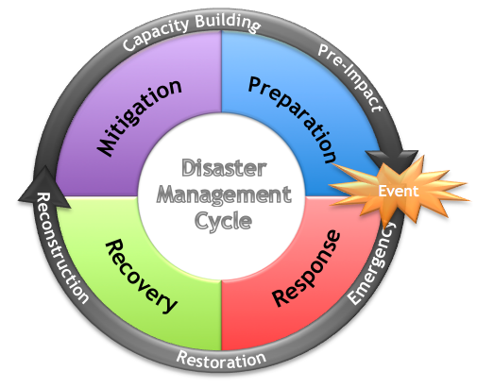
  - Remove all deadwood greater than 4-inch diameter
  - Structural prune weak attachments and co-dominant stems
  - Directional and Crown reduction pruning for clearance (streetlight, street sign, line of sight, athletic field, etc.)
  - Training pruning of young trees
- Identify dead and dying trees and schedule removal, stump removal and evaluate for replacement.
- All this work would be considered Mitigation in the Disaster Management Cycle. This would lead to greater Preparation, a more efficient Response, and a faster Recovery.

The benefits include:
- The City’s street and park trees would be pruned on a cycle, decreasing service requests
- A reduction in emergency responses
- More resiliency in the tree population to survive insect/disease outbreak, hurricanes, and storms
- A reduction in tree risk and liability

The City has spent more than 50 years focused on tree preservation and not urban forestry management. It will take many years to bring the tree management program up to date and proactively manage our natural resource.

Tree-Mendous Tampa Program FY2025
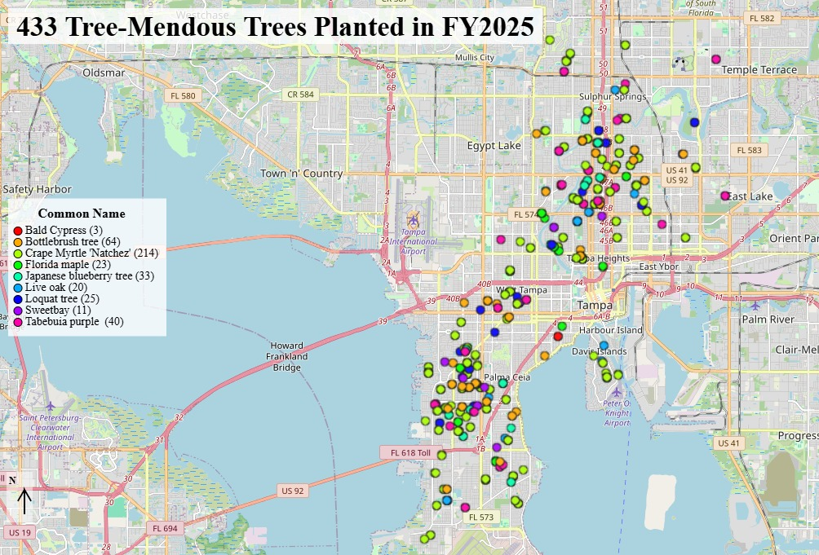
Top Ten Trees | Count | %
Crape Myrtle 'Natchez' | 214 | 49%
Bottlebrush Tree | 64 | 15%
Tabebuia purple | 40 | 9%
Japanese blueberry tree | 33 | 8%
Loquat tree | 25 | 6%
Florida maple | 23 | 5%
Live oak | 20 | 5%
Sweetbay Magnolia | 11 | 3%
Bald Cypress | 3 | <1%

The Forestry Division Tree-Mendous Tampa tree planting program provided 433 trees to residents who were willing to provide watering for one (1) year. Residents are allowed to choose their species and are only required to choose utility-appropriate species when overhead utilities are present. Most residents choose trees based on smaller mature size and aesthetics rather than the economic, environmental, and social benefits that trees provide. This leads to a decrease in Canopy.
There are 5 tools needed for Successful
Tree Canopy Resiliency, Preservation, and Expansion

- Preservation of the trees with the most potential – Saving only the biggest means that you are at the maximum canopy for that tree. Saving mid-size trees means that the canopy will expand in future years. Choose wisely.
- Aggressive planting in public spaces is encouraged but only if there is a commitment to maintain and manage the trees. The majority of property in a city is privately owned by people, businesses, or corporations. Property owners and developers must be engaged and encouraged to establish large-canopy species on their private property. The 2021 Canopy Assessment indicates that only 4.5% of planting sites that are adequate for large canopy trees are on Public Property.
- A well-staffed and funded street/park tree management program is required. The City should lead by example.
  - Street tree inventories are key to urban forest management and identifying potential planting sites.
  - Pruning cycles increase resiliency and extend the life of trees. This is the number one way to catch insect infestations and diseases early.
  - Structural pruning every 3 years, over the first 12 years, after planting determines the future resilience and sustainability of the tree.
  - Residents who lose a large tree due to tree failure are averse to planting large-canopy species as replacements.
- Necessary space above and below ground to plant, establish, and maintain large canopy species. The emphasis needs to be on locations for large canopy species.
  - Tree-Mendous Tampa planting guidelines
    - Avoid infrastructure conflict, utility conflict, and prevent sight obstructions
- A Citywide Vision of a Healthy, Resilient and Managed Urban Forest

Want more information? Read the article in the Florida Urban Forestry Council Quarterly Newsletter by scanning the QR Code.

“Department Mode” Completed Hurricane Work Orders
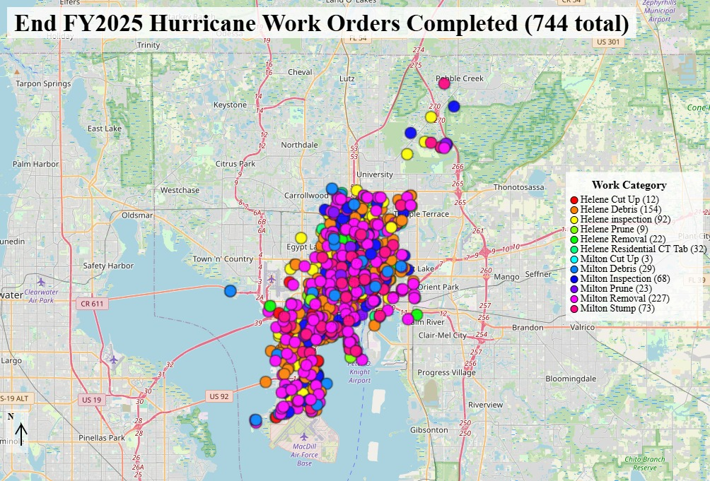

In FY2025, Forestry completed 744 Hurricane Work Orders.
What is the Significance of the Hurricane Work Orders?
The significance of the Completed Hurricane Work Orders is the De-Mobilization of the ERCs and returning to “Department Mode.” During ERC activation mode, the City has 30 push crews with 150-180 members. The State Emergency Road Access Team (ERAT) responded to Hurricane Milton with a 60-plus person team. Upon returning to department mode, all tree-related incidents not addressed by the Solid Waste Debris Hauling contractors are transferred to the Forestry Division.
What is the Forestry Response?
- The responsibility for the right-of-way trees and storm response is unclear.
- The City should consider a Post-Storm tree contract similar to the Solid Waste Debris Hauling Contract.
- Forestry receives work order requests through the Park and Rec Tree Line (residents), Customer Experience (CX) posts (residents), Crisis Track Reporting (residents, push crews, and damage assessors during the incident), Park Team field observations post storm, and Citywide Departmental emails.
- Work orders are entered in the Forestry Work Order management system and evaluated by the 2 Service Crew Leader IIIs.
- Work may be completed by the inhouse Forestry team or contractors.
  - Forestry spent $2.9 million completing 215 Hurricane related work orders
    - $2.1 million was spent addressing 61 parks, 4 cemeteries
    - $800,000 was spent at 132 ROW locations
- Mobility, Stormwater, Logistics and Asset Management, and Solid Waste are also utilizing the Citywide Tree contractors to address storm damage in their utility easements and properties.
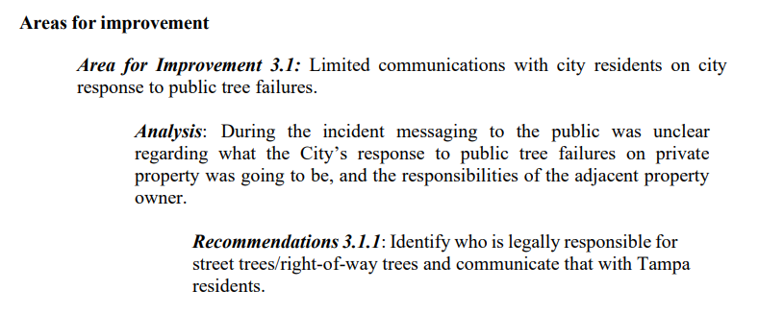
Completed Non-Hurricane Related Emergency Work Orders
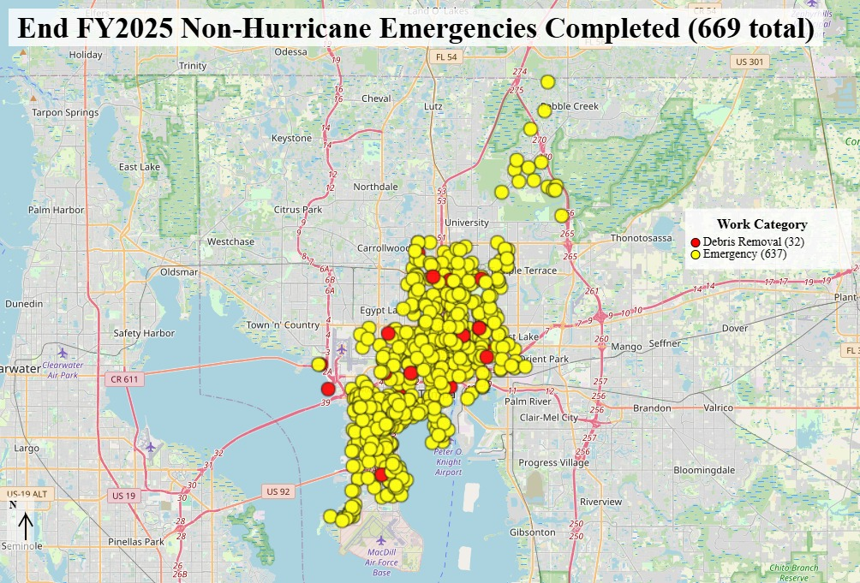

In FY2025, Forestry responded to 744 Hurricane work orders and 669 non-Hurricane emergencies, accounting for 48% of work orders completed.
What is an Emergency?
- Trees in the right-of-way or alleys that experience large branch or tree failure. These failures may affect the public right-of-way or private property.
- Trees in the City parks that experience branch or tree failure. These failures may affect a City park or private property.
- Trees on private property that experience branch or tree failure affecting the public right-of-way, alleys, or City parks.
- Trucks and/or City vehicles stuck under low leads or that have knocked down limbs.
- Vehicle accidents involving trees in the public right-of-way.
What is the Forestry Response?
- Weekdays (7:00 a.m. – 3:30 p.m.) – Forestry crews are re-directed from pruning and removal projects to provide response.
- Nights (M-F 3:30 p.m. – 12:00 a.m.) and Weekends (8:00 a.m. – 12:00 a.m.) – A 2-person forestry crew is on call and responds to clear the road. The debris is stacked in the right-of-way to be picked up on the next scheduled workday.
- Use of Contractors – large-scale park cleanup projects are contracted out due to Forestry staffing limitations. Technical removals involving a crane are contracted.
What are the Implications?
- Staff is too busy responding to emergencies to address pruning and removal requests during storm season.
- Forestry rents two (2) lightning loaders.
- Forestry inspections take 6-8 weeks during storm season due to staff responding to emergencies.
- Forestry does not provide an estimate for non-emergency work completion during storm season.
- Risk Management deals with numerous claims annually due to public tree failure damage to private property.
- Significant backlog of work orders starting FY 2026 (300 work orders open).
Completed Tree Removal/Stump Removal Work Orders
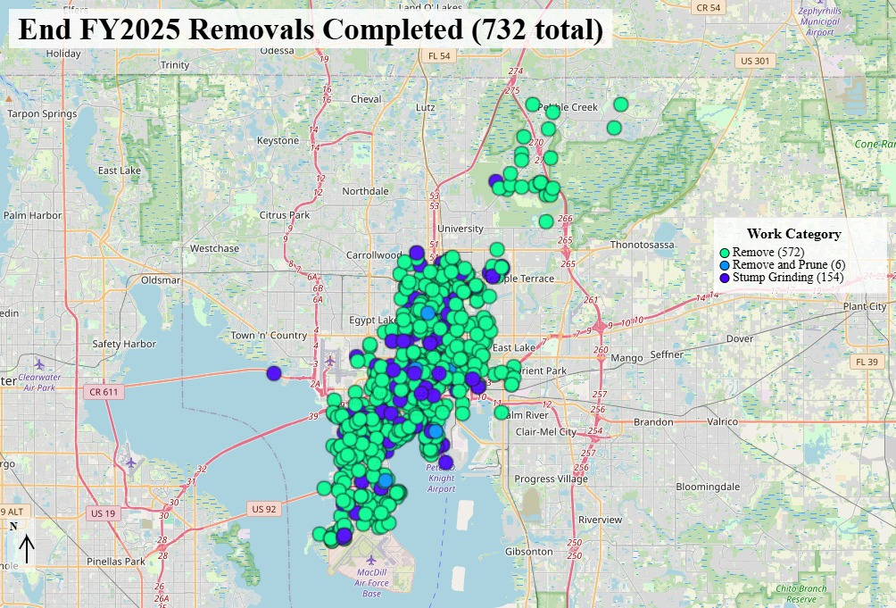

In FY2025, Forestry completed 732 tree and stump removal work orders.
Criteria for street, park, or alley trees removal:
- Dead, dying, diseased trees
- Structurally compromised trees
- Trees with significant structural failures
- Trees with a high risk of failure
What is the Forestry Response?
- One Forestry crew is available to perform tree removals outside of storm season
- The Forestry Division also utilizes contractors for tree removals:
  - Removals requiring a crane are contracted out
  - Three (3) contractors completed 224 work orders removing 296 trees in FY2025
What are the Implications?
- Staffing is affecting the ability to operate a removal crew and address necessary removals.
- Strict tree preservation guidelines have increased the number of overmature/senescent trees in the public right-of-way, alleys, parks, and private property affecting the ROW.
- Trees often experience storm damage and significant failure prior to removal. Human Resources Claims receives reports of personal injury and damage to private property including fences, vehicles, and houses.
- Once scared by large-tree failure, adjacent residents prefer no replacement planting or replacing old, large-tree species with a smaller growing species as a way of reducing fear. This has a negative impact on the overall tree canopy and the associated economic, environmental, and social benefits.

Completed Pruning Work Orders
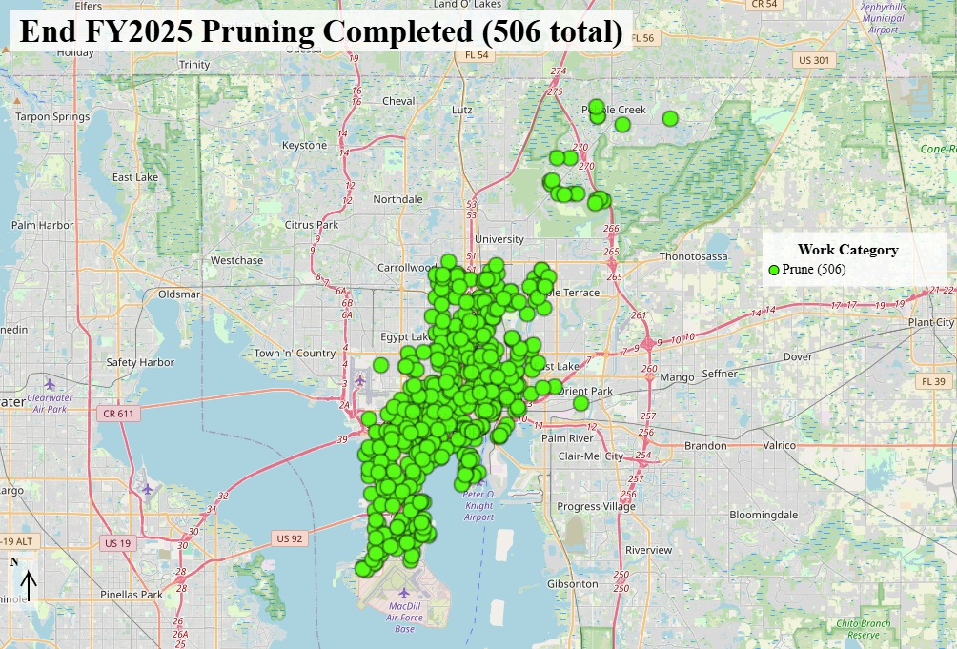

In FY2025, Forestry completed 506 pruning work orders.
What are the reasons that pruning work orders are generated?
- Trees in the right-of-way or alleys obstructing vehicle/pedestrian traffic.
- Trees in the right-of-way or alleys obstructing traffic control devices and vision.
- Trees in the right-of-way or alleys having conflicts with streetlights.
- Park trees having branch conflicts with infrastructure including, but not limited to, buildings, lighting, playground structures, athletic facilities, trail, and path clearance, etc.
- Street or Park trees having significant dead branches (4-inch diameter or greater).
- Private vegetation causing sidewalk/pedestrian obstruction, street obstruction, or a sight obstruction.
- Mobility school zone sign and light clearance.
- Crime Prevention through Environmental Design (CPTED) working with TPD.
What is the Forestry Response?
- Use of Contractors – large-scale pruning projects are contracted out due to Forestry staffing.
- TECO and their contractors are Line Clearance Certified. They are the only ones allowed to work within 10 feet of any overhead utility by ANSI standards.
- Two-Person forestry crew for 1- to 6-tree projects.
  - Crew size expands as the number of trees increases, or traffic safety concerns increase.
- Private property issues are the resident’s responsibility by City Ordinance Chapters 19 and 22. As of March 2025, Forestry is pruning private property trees encroaching into the right-of-way.
What are the Implications?
- Staffing is affecting the ability to operate a large pruning crew.
- Without a street tree inventory the City is unable to determine how many trees need to be pruned annually to develop a tree pruning cycle.
- The First Key to Urban Forest Resilience is diversity of species. Pruning is the second key to sustainability and resilience. Proactive cyclical pruning reduces risk, mitigates failure, improves right-of-way clearance, and allows for quicker identification of disease and insect outbreaks.
Neighborhood Enhancement Work Orders
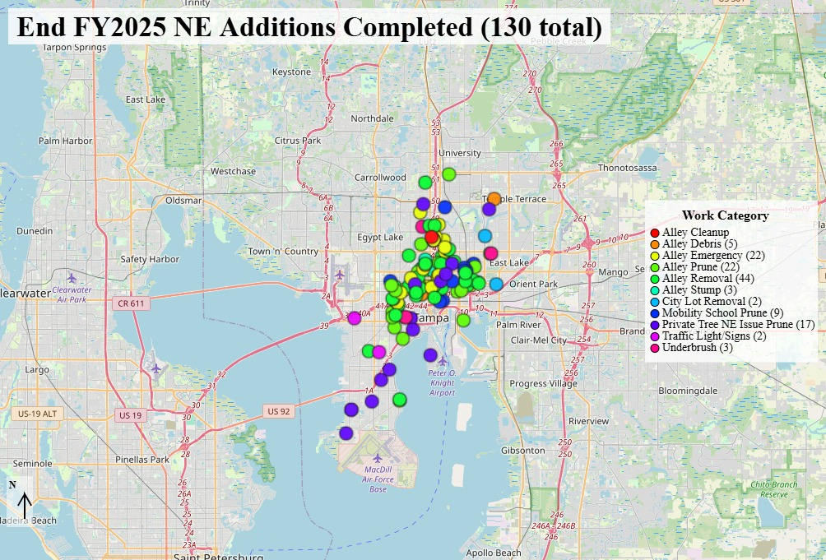

In FY2025, Forestry completed 130 work orders involving alleys, City-owned lots, or private vegetation causing issues with the public right-of-way.
In March 2025 the Forestry Division was moved from Parks and Recreation to Neighborhood Enhancement (NE), combined with the NE Tree Team, and is now taking on additional tree work responsibilities to avoid duplication of services. These responsibilities include alleyways, stop sign clearance, streetlight clearance, City-owned vacant lots, and private vegetation encroaching into the public right-of-way.
What is the Forestry Response?
Forestry now responds to tree issues on:
- 1,200-plus miles of Rights-of-Way (ROW) and medians
- 355 miles of alleys (paved, unimproved, and abandoned)
- 8 Cemeteries
- 196 Parks
- Mobility signage/lighting issues
- Crime Prevention through Environmental Design (CPTED) working with TPD
- Private vegetation encroaching into the public right-of-way
What are the Implications?
The overwhelming distribution of tree authority, both public and private, has created confusion for residents and City Departments alike. The combination of the Neighborhood Enhancement Tree Team and the Forestry Division reduces some of the confusion.
Work Orders Transferred to Other Entities
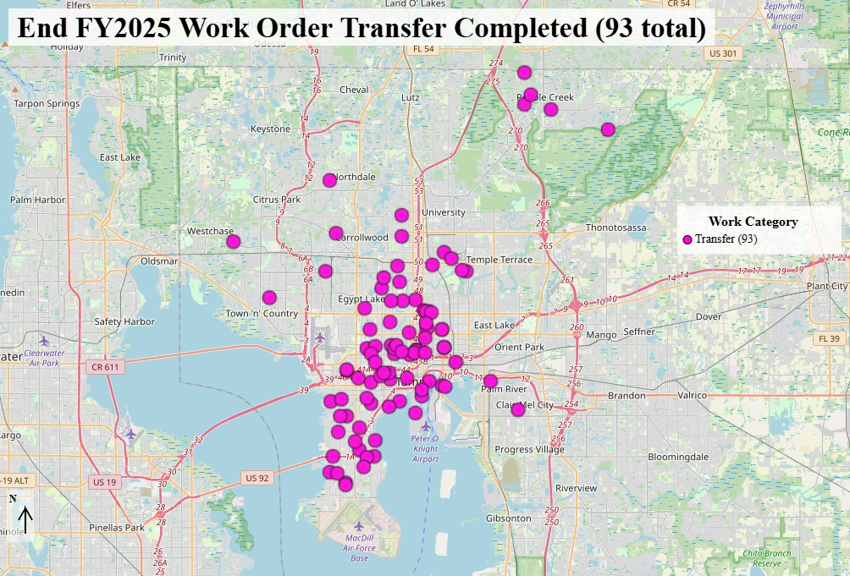

In FY2025, Forestry transferred 93 work orders to other entities.
Why are Work Orders Transferred?
The City of Tampa lacks a public tree ordinance authorizing a single City Department or Division to determine the planting, management, and removal of trees. Instead, in Chapter 27 Zoning and Development, the Forestry Division receives an exemption from “obtaining permits for pruning (limb/root) of any protected or grand tree on public land or public right-of-way; and removal of any protected tree or hazardous/dangerous grand tree, to mitigate any potential risk to the safety of the general public, on public lands or public rights-of-way.” (Sec. 27-284.1.3. - Other exemptions)

City Departments and other entities with tree related responsibilities:
- Development and Growth Management Natural Resources Team – Tree permit issues and Illegal Tree Removals
- Planning – Tree Canopy Study, the Urban Forest Management Plan update, establishing the Natural Resources Advisory Committee (NRAC) and landscape-scale planting projects
- Sustainability – Planting projects
- County – County Road trees, and calls from residents outside the City Limits
- TECO – utility line clearance
- Solid Waste – private property storm debris
- Stormwater – trees in designated drainage facilities and easements
- Mobility – healthy street trees with roots heaving sidewalks, driveways, or curb
- Water Department – healthy street tree roots conflicting with the water meter
- Areas where the Community Development District (CDD) or Homeowner’s Association (HOA) has been designated the responsible party for street trees
- Maintenance Agreements – Select downtown trees that are to be maintained by the adjoining property
What is the Forestry Response?
- The Forestry Division tries to facilitate communication between the requestor and the proper authority.
What are the Implications?
- The overwhelming distribution of tree authority, both public and private, has created confusion for residents and City Departments alike.
End FY25 Open Work Orders
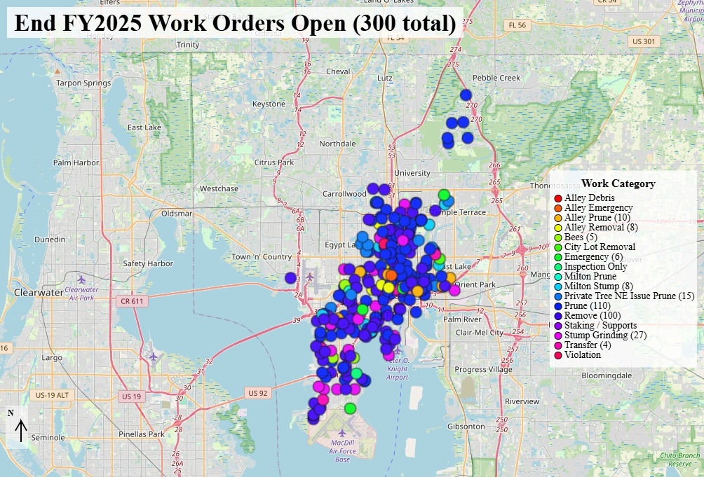

At the start of FY2026, Forestry began with a backlog of 300 work orders. This is the lowest backlog that we have experienced since FY2018.
What is the Main Cause of the Backlog?
The main cause of the backlog is the number of tree failures that occur during storm season (June through November). Forestry Crews are called off projects to tend to tree emergencies affecting City streets, alleys, and parks.
What is the Forestry Response?
- During storm season (June – November) Forestry staff is too busy responding to emergencies to address pruning and removal requests.
- Forestry inspections take 6-8 weeks during storm season due to staff responding to emergencies.
- Forestry does not provide an estimate for non-emergency work completion during storm season.
- Most non-emergency work completed by Forestry staff is limited to December through May.
- Large projects are contracted out, including neighborhoods, long stretches of roads, area pruning, and Park pruning projects.
- Mobility, Stormwater, Logistics and Asset Management, and Solid Waste are utilizing the Citywide Tree contract to prune street trees to meet the clearance needs of their individual departments. This includes, but is not limited to:
  - Traffic control clearance
  - Drainage ditch and stormwater pond tree management
  - Vehicle clearance
  - Parking lot and City Facility tree management
What are the Implications?
Until the Forestry Division is staffed and funded to proactively manage the street and park tree populations, the amount of tree failures will continue to affect the number of backlogged requests. The 2021 Urban Forestry Strategic Plan was developed to identify and resolve the program’s staffing issues.

What do other communities do? (census.gov)
Tampa is the 49th largest city in the United States. An online review of 39th ranked Colorado Springs, Colorado to 59th ranked Riverside City, California urban forestry programs reveals a diverse urban forestry management spectrum. The management classifications are best described as:
- Proactive – Wichita, Kansas and Honolulu, Hawaii
  - Up-to-date street tree inventory
  - Systematic (Cycle/Area) pruning and planting
  - Annual City-wide Inspections for poor category trees
  - Risk management program
  - Post planting tree care (watering, staking, mulching, training pruning)
- Systematic Reactive – Aurora, Colorado
  - Street tree inventory may be old or out of date
  - Systematic pruning cycle exceeding 10 years
  - No Annual City-wide Inspections for poor category trees
  - Risk management program must prioritize based on severity
- Reactive – Cleveland, Ohio
  - No street tree inventory
  - No systematic pruning cycles
- Reactive Deferred – City of Tampa and New Orleans, Louisiana
  - No street tree inventory
  - No systematic pruning cycles
  - Resident/Department requests drive 100% of the workload
  - Residents request to hire their own tree service for street tree work
- Deferred - Arlington, Texas and Bakersfield, California
  - Responsibility for neighborhood street trees is assigned to the adjacent landowner

Forestry SWOT Analysis
Strengths
- The Forestry Division has obtained a computerized work order management system and tree inventory program.
- Reporting and accountability have improved through the creation of the annual State of the Forest report.
- The Forestry Crew is comprised of smart, courteous, and safety-conscious staff.
- Forestry works as a team.

Weaknesses
- The number of emergency responses restricts our ability to address the growing backlog of service requests (48% of work completed is an emergency response, FY2025).
- Insufficient guidance on responsibility for street trees and alley situations (ROW trees).
- Permit process may be hindering private tree care.
- The Forestry Team size and budget are not meeting the management needs of the street and park tree populations.
- One Forestry Team member is not enough for an appropriate street tree planting program.

Opportunities
- Create a public tree ordinance either assigning street tree maintenance to the adjacent property owner or authorizing the Forestry Division to determine the planting, management, and removal of trees in the public right-of-way and parks.
- Collect a City-wide street tree inventory.
- Updates to Forestry job descriptions and salary adjustments are needed to attract and retain qualified personnel. A workforce development plan would assist with bringing in and training new personnel.
- Develop a Post Storm Tree Work Contract similar to the Debris Hauling contract

Threats
- Hurricanes and storms always present a risk.
- Aging/Senescent public tree population.
- Tampa is an international port community and is susceptible to the potential invasion of non-native invasive tree pests/diseases that could dramatically affect the urban forest.
- The limited maintenance of trees has resulted in claims against the City and significant damage to City vehicles.
- Tree/branch failure is a regular occurrence.
Recommendations

The current Forestry Operating Procedure is:
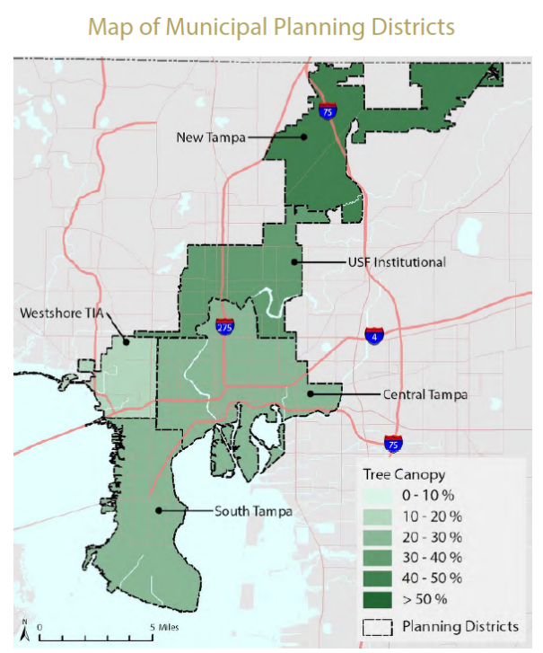
- Receive a Service Request
- Call the requestor within 2 days to notify them that we will inspect within 2-3 weeks (6-8 weeks in storm season, June through November).
- Upon inspection, priority work is scheduled at 3-6 months, all other work is scheduled up to 12 months or longer. Notify the requestor of the schedule.
- If we maintain status quo, we will continue to fall behind.

It is recommended that the City incorporate an Area Management Cycle to address the management needs of the street and park trees and reduce the number of incoming requests. The Urban Forestry Program should be equally active in all five (5) Planning Districts.

Area Management Cycle (Best Management Practices)
The Goals for management would be:
- Healthy street and park trees:
  - Raise the canopy for eventual permanent 16-foot clearance over the road and a balanced canopy over the sidewalk
  - Remove all deadwood greater than 4-inch diameter
  - Structural pruning of weak attachments and co-dominant stems
  - Directional and Crown reduction pruning for clearance (streetlight, street sign, line of sight, traffic control, etc.)
  - Training pruning for young trees
- Identify dead and dying trees and schedule removal, stump removal, and evaluate for replacement
- Management Cycles would address Mitigation in the Disaster Management Cycle. This would lead to greater Preparation, a more efficient Response, and a faster Recovery

Please note that utility line pruning is done by TECO or its contractor on a 3- to 5-year cycle. City crews must maintain a distance of 10 feet from utility lines as they are not line-clearance certified.
This work would require:
- A Street tree inventory that identifies trees in the right-of-way, assigns a condition class, identifies high-risk trees, locates available planting sites, and promotes proactive Urban Forestry management
- A commitment to grow, equip, and fund a larger in-house workforce capable of meeting the management needs of the Urban Forest
- A review of Forestry Team job descriptions and salaries
- An appropriate budget for the Forestry Program
- An outreach program to improve communication with residents
- Work should begin in the USF Institutional and Central Tampa Planning Districts

This would provide:
- Equitable Urban Forestry Management across the five (5) Planning Districts
- A reduction in service requests
- A reduction in emergency responses
- A reduction in vehicle/tree conflict
- A reduction in infrastructure conflicts
- A reduction in municipal vehicle damage and expense
- More resiliency in the tree population to survive storms and insect/disease outbreaks
- A monitoring program that would potentially detect new invasive species early
- A reduction in risk and liability as the City begins to manage the tree population proactively, instead of reactively

The Forestry Division Strategic Plan is directly tied to the City of Tampa Urban Forest Management Plan, Resilient Tampa Roadmap, Climate Action and Equity Plan, and Tampa Heat Resilience Playbook and was developed to address the shortcomings of the current program including, but not limited to:
- Develop a street tree inventory
- Reduce tree failures
- Increase the Urban Tree Canopy through an aggressive planting program
- Reduce tree/vehicle conflicts in the right-of-way
- Proactively manage the Urban Forest Canopy

It’s time to start thinking differently about urban trees, viewing them as the important municipal asset they are and providing the conditions they need to thrive.
- Jacob Westlin, A Case for Trees as Municipal Assets; Deep Root Blog August 2025

