[Insert Company Name]
Disaster Preparedness Plan
YOUR KEY TO DISASTER RESILIENCY

[Insert Your Company Logo Here]
[Insert Date]

Responsible Party: [Insert name]
Additional Resources: [Insert name/s]


Provided by

Table of Contents

Introduction 1
Business Goals 2
Critical Business Functions & Resources 3
Hazards 4
Our Backup Suppliers 5
Our Backup Distributors 6
Business Impact Analysis 7
Emergency Response Plans 8
Emergency Communication Plan 9
Business Resiliency Plan 10
Preventative Measures 13


Introduction

This Disaster Preparedness Plan is meant to work with Florida SBDC Network’s Small Business Disaster Preparedness Guide. The goal is for you to create a plan that will help you respond to most emergency situations and recover as quickly as possible. If more space is needed on any of the tables provided in this worksheet, they are provided on a single page, so that you can print out more copies.

Start by identifying your critical business functions and their supporting resources. Using the Disaster Preparedness Guide, identify risks your business could face, including ones that may not be listed in the guide. Analyze how these risks could affect your critical business functions and resources, including cashflow. With this information you can create your business preparedness plan, as well as the Emergency Communication Plan from the Disaster Preparedness Guide. Then fill in the preventative measures you can take to mitigate risk from your most likely hazards, and perhaps unlikely sources. The final step is making the necessary contacts or preparations so that you are ready to implement your plan when it is needed.

In the identify section of the Disaster Preparedness Guide, you identified the hazards your business is most exposed to and their severity. The last section of this Disaster Preparedness Plan provides a template for you to take those hazards and develop Emergency Response Plans. These plans encompass both preparation for hazards and the appropriate actions to take in reaction. The Florida SBDC Network website has resources you can use to help develop your Emergency Response Plans, including a template specific to Emergency Procedures.

Business Goals
(p. 4 of the Disaster Preparedness Guide)

BUSINESS GOALS
1.
2.
3.
4.
5.
6.
Notes:

Critical Business Functions & Resources
(p. 6 of the Disaster Preparedness Guide)

These are our critical business functions and the resources they need. Without these our company cannot continue to operate.

CRITICAL BUSINESS FUNCTIONS & RESOURCES
Critical Business Function | Supporting Resource(s) | Function of  Resource | Backup  Resource(s)

Hazards
(p. 10 of the Disaster Preparedness Guide)

Our business is exposed to the following hazards. These could affect our critical business functions, preventing us from continuing business.

TYPES OF HAZARDS
Hazard | How  Likely?  (1-5) | How  Severe?  (1-5) | Risk | Notes

The scales and risk matrix below can be found on pages 8-9 of the Disaster Preparedness Guide.
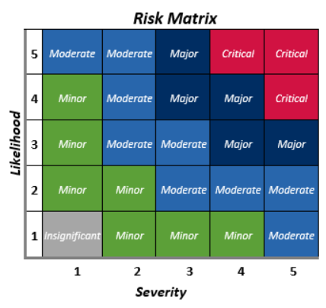
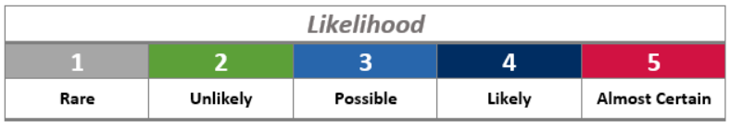

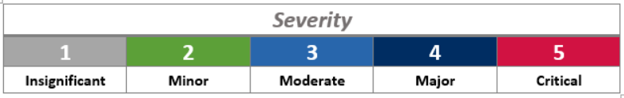
Our Backup Suppliers
(p. 11 of the Disaster Preparedness Guide; reproduce page as needed)

SUPPLIERS: TYPES OF HAZARDS
Supplier  Name | Resources Supplied | Threats They Face | How  Likely?  (1-5) | How  Severe?  (1-5) | Risk
Backup Supplier 1
Address
Contact Name |  | Email
Phone |  | Fax
Materials/Services |  | Account #
Backup Supplier 2
Address
Contact Name |  | Email
Phone |  | Fax
Materials/Services |  | Account #
Backup Supplier 3
Address
Contact Name |  | Email
Phone |  | Fax
Materials/Services |  | Account #
Backup Supplier 4
Address
Contact Name |  | Email
Phone |  | Fax
Materials/Services |  | Account #

Our Backup Distributors
(p. 11 of the Disaster Preparedness Guide; reproduce page as needed)

DISTRIBUTORS: TYPES OF HAZARDS
Distributor  Name | Product  Distributed | Threats They Face | How  Likely?  (1-5) | How  Severe?  (1-5) | Risk
Backup Distributor 1
Address
Contact Name |  | Email
Phone |  | Fax
Materials/Services |  | Account #
Backup Distributor 2
Address
Contact Name |  | Email
Phone |  | Fax
Materials/Services |  | Account #
Backup Distributor 3
Address
Contact Name |  | Email
Phone |  | Fax
Materials/Services |  | Account #
Backup Distributor 4
Address
Contact Name |  | Email
Phone |  | Fax
Materials/Services |  | Account #
Business Impact Analysis
(p. 13 of the Disaster Preparedness Guide)

If one of the above threats takes place, these will be the likely business functions and resources affected. If one of these resources or functions is lost, we should work quickly to replace it.

BUSINESS IMPACT ANALYSIS
Disaster | Business Functions  Impacted | Resources  Impacted | Recovery Time Objective | Operational Impacts | Financial Impacts
Emergency Response Plans
(p. 14 of the Disaster Preparedness Guide)

[INSERT EMERGENCY] EMERGENCY RESPONSE PLAN
[Insert Company Name]
Last Updated: [Insert Date] | Next Update: [Insert Date]
Person responsible for this plan: [Insert Name]

PREPARATION:  [Insert Procedure/s] | RESPONSIBLE PERSON:  [Insert Name/s]
ACTION:
[Insert Action/s]

Emergency Communication Plan

(p. 16 of the Disaster Preparedness Guide)

CONTACTS
Name | Role | Phone & Address
METHODS OF COMMUNICATION
(cell phone, social media, person-to-person)
Method | Person  Responsible | Notes
Person responsible for this plan:

Business Resiliency Plan

(p. 19 of the Disaster Preparedness Guide)

This is our plan of action following a disaster. By following this we will be able to keep our business in operation or return to operation as quickly as possible.

These are the critical business functions we need to run our business:

CRITICAL BUSINESS FUNCTIONS
Critical Function | Recovery Time Objective | Staff In  Charge | Resources Needed | Backup  Resources

This is our backup business location we will use if our primary office is compromised:
(p. 19 of the Business Resiliency Guide)

BACKUP BUSINESS LOCATION
Name of Backup Location:
Address:
Phone Number:
Name of Person Responsible for Contacting:
Contact Information:
Map: | [Insert map with backup location marked here]
We have prepared a Business Ready ‘Records-To-Go’ box that includes information and documents needed to continue business and to apply for state and federal disaster loans, if necessary.
(p. 20 of the Business Resiliency Guide)

The information and documents included in our Business Ready ‘Records-To-Go’ box are checked below.
LIST OF INFORMATION & DOCUMENTS
 | Disaster Preparedness, Business Resiliency, and Recovery Plan |  | Legal structure or incorporation papers
 | Emergency contact list of employees and key customers |  | Name, social security number, contact information, and percentage of ownership for each owner
 | Insurance policies and agent information |  | List of business key creditors and vendors
 | List of suppliers and distributors |  | Business tax returns
 | Customer records |  | Personal tax returns for each owner
 | Back-up computer systems and data files |  | Employee verification documentation (e.g. IRS Form 941, W-3s, W-2s)
 | Bank records |  | Schedule of liabilities and debts of the business
 | Physical address of the business |  | Current year –to-date financial statement (profit and loss, balance sheet, and cash flow statements)
 | Tax identification numbers |  | Other (list)
These are our step-by-step procedures for following our Business Resiliency Plan:
(p. 20 of the Business Resiliency Guide)
PROCEDURES
- We will first identify if our primary location is usable. | Person Responsible:
- The recovery team will meet at our primary location if usable; at the backup location if unusable. | People Involved:
- We will contact each person in charge of critical business functions. They will identify  if the critical function is still working and initiate a backup if needed. | Person Responsible:
- Initiate our Emergency Communication Plan. | Person Responsible:
- If it is determined that our primary supplier or distributor is compromised, we will contact our backup. | Backup/s:
- Decide what the next step for our business is based on the disaster and impacts. | Person Responsible:

Preventative Measures
(p. 21 of the Disaster Preparedness Guide)

What are some proactive preventative measures your business could take to mitigate risk?

PROACTIVE PREVENTATIVE MEASURES
Hazard | Measures

