Lighthouse for the
Blind & Low Vision

FIRST ANNUAL
WHITE CANE WALK!
Saturday, Oct 15, 2022 9:00 am – 12:00 pm

Al Lopez Park
4810 N. Himes Avenue, Tampa, FL 33614

    - Enjoy this fundraiser with your company and/or your friends and family!
    - Help raise awareness and support for the blind and visually impaired in our community.
    - The morning will be a fun family event with food, beverages, games, activities and a 1-Mile Walk!

Support the Lighthouse Mission

- Corporate sponsorships are available, and we can tailor one to fit your company’s needs.
- Be a Team Captain and start a fundraising Walk Team!
- Be an Individual Walker or join an existing Walk Team and fundraise for incentives!

To Register for the Walk:
https://secure.qgiv.com/event/tampawcw2022/

Additional information will be coming soon!
Feel free to contact Sherry Yagovane at 813-251-2407 ext. 21
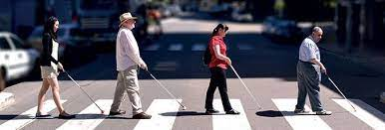
or sherry.yagovane@lighthouseblv.org

